How Your Tax Dollars Are Spent
Based on Operating Budgets

SERVICES/DEPARTMENTS | Budget(%) | Budget($)
General Government | 5.79% | 1,499,814
Public Safety | 10.79% | 2,795,093
Education | 68.90% | 17,847,522
Public Works | 6.11% | 1,583,588
Human Services | 0.79% | 206,101
Culture & Recreation | 2.13% | 551,903
Debt Service | 4.87% | 1,262,688
Employee Benefits | 5.63% | 1,458,596
Other Insurance | 0.44% | 115,737
TOTAL TO BE SPENT | 100% | 25,899,870

Approximate Cost of Services
to the Average Homeowner

General Government | 749.38
Public Safety | 1396.52
Education | 8917.55
Public Works | 790.80
Human Services | 102.24
Culture & Recreation | 275.68
Debt Service | 630.31
Employee Benefits | 728.67
Other Insurance | 56.94

TOTAL AVERAGE TAX BILL $ 12,942.75
(Based on average, single family
home valuation of $795,926)

Valuations by Property Class

Property Class | Accts | Valuation
Mixed Use | 13 | 40,996,538
Single Family Homes | 1747 | 1,390,483,100
Condominiums | 124 | 53,758,000
Mobile Homes and Other Res | 14 | 15,864,800
Two Family Homes | 15 | 7,669,000
Three Family Homes | 0 | 0
Apartments 4 - 8 Units | 1 | 531,800
Vacant Land | 25 | 18,169,900
Open Space | 0 | 0
Commercial | 34 | 31,292,800
Industrial | 12 | 12,151,300
Personal Property | 69 | 25,738,840
Forest Lands - Chapter 61 | 16 | 24,401
Agricultural - Chapter 61A | 51 | 1,279,761
Recreational - Chapter 61B | 39 | 2,514,500
TOTAL TAXABLE | 2360 | 1,502,304,073
Exempt Properties |  | 63,228,800
TOTAL TAXABLE & EXEMPT |  | 1,600,474,740

History of Valuations, Tax Rates, and Levies
Fiscal Year | Valuation | Tax Rate | Tax Levy
2024 | 1,600,474,740 | 16.26 | 26,023,719.28
2023 | 1,442,380,880 | 17.50 | 25,241,665.00
2022 | 1,214,488,080 | 19.87 | 24,131,878.15
2021 | 1,126,570,210 | 20.86 | 23,500,254.58
2020 | 1,114,630,277 | 20.39 | 22,727,311.35
2019 | 1,056,865,701 | 20.47 | 21,634,040.90
2018 | 1,019,535,722 | 20.66 | 21,063,608.02
2017 | 961,512,639 | 21.2 | 20,384,067.95
2016 | 934,606,956 | 20.91 | 19,542,631.46
2015 | 898,801,476 | 20.98 | 18,856,854.97
2014 | 873,687,629 | 21.2 | 18,522,177.74
2013 | 859,744,392 | 20.96 | 18,020,242.46
2012 | 880,376,239 | 19.78 | 17,413,842.01
2011 | 925,371,662 | 19.42 | 17,053,384.84
2010 | 931,523,796 | 17.61 | 16,404,134.04
2009 | 971,947,836 | 15.91 | 15,463,690.08
2008 | 969,350,160 | 15.05 | 14,588,719.91
2007 | 987,612,731 | 14.06 | 13,885,834.99
2006 | 961,378,148 | 13.56 | 13,036,287.69
2005 | 877,046,810 | 13.97 | 12,252,343.94

Town of Bolton
Valuation and Tax
Summary

Fiscal Year 2024

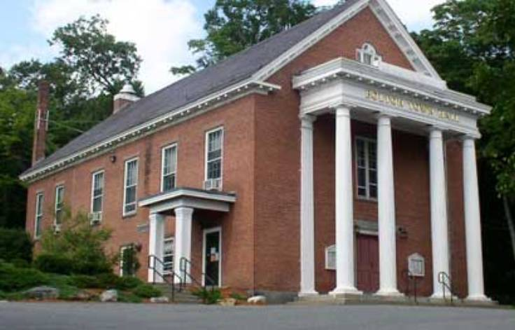

Prepared by the Board of Assessors
Jeffrey Nichols, Chairman
Charlotte Johnson, Member
Wendy Rogers, Member
Kelly Garlock, Assistant Assessor
David Manzello, Regional Assessor
Alex Cervone, Regional Associate Assessor

THE ROLE OF ASSESSORS IN MUNICIPAL FINANCE

In Massachusetts, assessors are either appointed or elected to three-year terms. The assessors’ primary responsibility is to value all real estate and personal property subject to taxation. Assessed valuations are based on “full and fair cash value” as of the January 1st preceding each fiscal year.

In order to maintain assessments at or near market value, the assessors’ regularly compare property valuations with the selling prices of properties that have sold. Assessment-to-sale ratio statistics are analyzed to determine the median assessment level, as well as, assessment uniformity.

No valuation methodology can accurately predict what a property will sell for. A secondary, and perhaps more important role of the Board of Assessors is to generate equitable assessments. To that end we continually strive to maintain an accurate property database and refine valuation tables and formulas that yield both equitable and explainable assessments.

ABATEMENTS

All taxpayers have the right to file for an abatement of their taxes if they believe that their property has not been fairly valued. Information regarding applications and deadlines to file for abatements is printed on tax bills, or can be obtained by calling the Assessors’ Office at 978-779-5556. Applicants should present compelling evidence to support a claim of overvaluation.

EXEMPTIONS

An exemption releases an individual from the requirement to pay all or a part of their property tax obligation. Exemptions are available to those individuals that meet the various requirements in the following categories:
- Elderly
- Blind
- Minor children of police/firefighters killed in the line of duty
- Disabled Veteran
- Widows or Widowers
- Orphaned Minor Children

DEADLINES

Applications for abatements are due on or before the due date for payment of the 3rd quarter bill (February 1st, 2024). Mailed applications must be postmarked no later than 2/1/2024.

Applications for personal exemptions are due on December 15th, or within three months of the mailing date of the 3rd quarter bill.

APPEALS

If you are not satisfied with the action taken by the Board of Assessors office regarding your request for abatement and/or exemption, you have the right to appeal to the State Appellate Tax Board, 100 Cambridge St. Boston, MA 02204 (617-727-3100).

Summary of Appropriations and Revenues

APPROPRIATIONS & OTHER EXPENDITURES
Total Appropriations of Town Meeting | 29,506,269.92
Cherry Sheet Offsets | 13,350.00
Debt and Interest Charges | 0.00
Snow and Ice Deficit | 0.00
Misc. Deficits to be Raised | 0.00
State and County Charges | 74,151.00
Allowance for Abatements & Exemptions | 102,163.88
TOTAL | 29,695,934.80

ANTICIPATED REVENUES
Property Tax Levy |  | 26,023,719.28
State Distributions – Education
Chapter 70 |  | 0
MA. School Bldg Authority Payments |  | 0
State Distributions - General Government
General Government Aid |  | 236,028
Police Career Incentive |  | 0
Exemption Reimbursements |  | 24,043
State Owned Land |  | 20,123
Veterans’ Benefits |  | 19,349
Public Libraries |  | 13,350
Local-Non-property Tax Revenues (anticipated)
Motor Vehicle Excise | 1,062,996.40
Other Excise-Meals | 66,131.68
Other Excise- Room | 10,980.12
Penalties and Interest- taxes and excises | 75,470.96
Fees | 208,357.35
Rentals | 7,600.00
Departmental Revenue-Schools | 78,558.48
Licenses and Permits | 145,490.98
Fines and Forfeits | 71,176.89
Investment Income | 46,561.09
Miscellaneous – Recurring | 207,024.98
Miscellaneous – Non-Recurring | 0
Other
Free Cash | 578,250.68
Other Available Funds | 626,303.84
TOTAL REVENUES: $__ | 26,023,719.28

